3.3V Current Demand Verification:

3V3 Regulator P/N: MCP1725-3302E/SN
Maximum Current: 500 mA
Dropout: 210 mV (typical)
Input Voltage Range: 3.51 – 6.0 V

3V3 Devices and maximum current

PIC18F45J10 | 250 mA (absolute max per datasheet)
1206 SMT LEDs | 25 mA (x6) (maximum source current)
U501 GPS Receiver | 38.33 mA (maximum search mode)
MiWi | 23 mA (maximum transmit power)
Total | 461.3 mA
Available Current | 500 mA
Current Margin | 38.7 mA

Note: PCA9600 VCC is driven by 5V I2C bus power

3V3 Regulator Circuit Verification:

Section 4.4 of MCP1725 calls for an input capacitor of at least 1.0-4.7 uF.

For resilience against transients when using the board in an I2C bus powered mode, 10 uF capacitors were selected (as shown in figure 5-1 on datasheet).

PCA9600 Bias Circuit Verification:

The discrete components used for the PCA9600 active terminator were chosen from the datasheet:

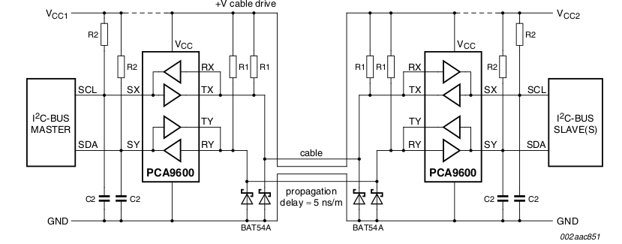
With values chosen from the following table (line three):

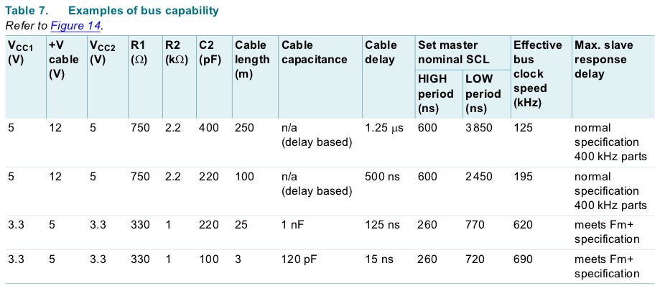
Xtal Oscillator Capacitor Loading Verification:

Part Number: ECS-200-18-4XEN

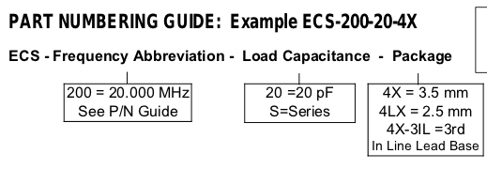
This requires 18 pF in parallel across the crystal oscillator. Therefore each capacitor should be 9pF.
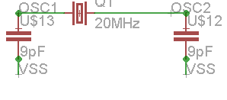

Device Pinout Verification:

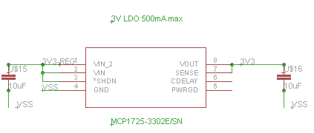
3V3 Regulator:
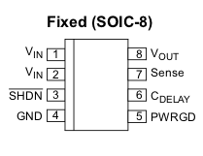

MiWi Module:

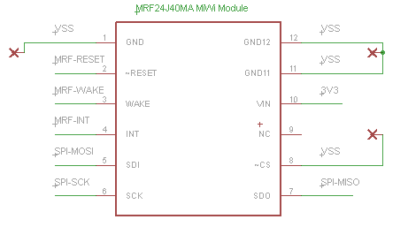

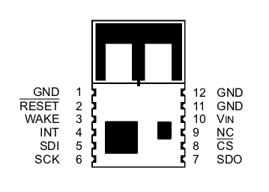

PCA9600 Active Terminator

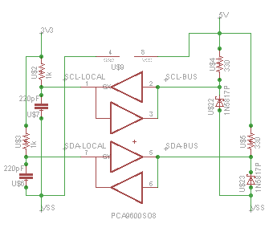

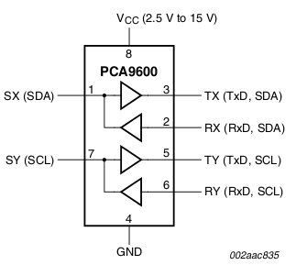

5V Regulator Pinout:

Part Number: L78S05CV

Datasheet Recommended Capacitors:
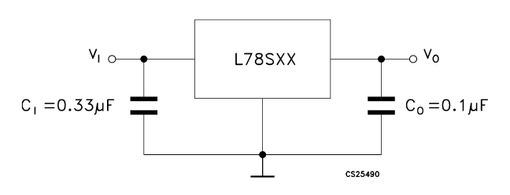
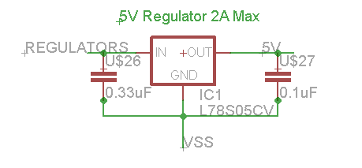

Confirming physical layout of 5V Regulator:
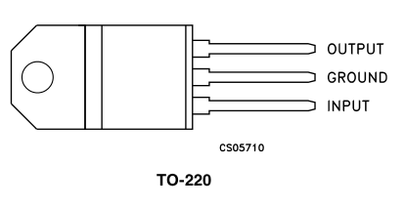

On the actual PCB (from left to right, 5V, VSS, REGULATORS)
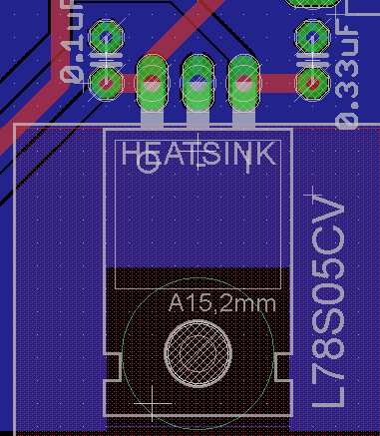

PIC18F45J10 Pinout verification

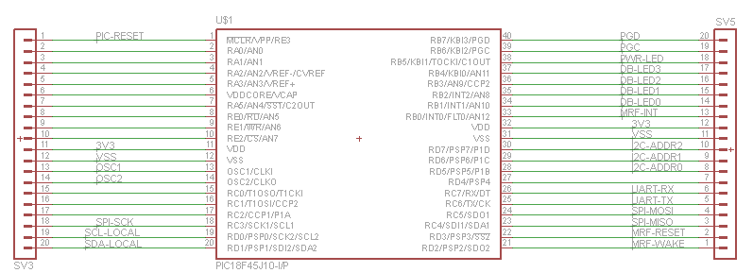
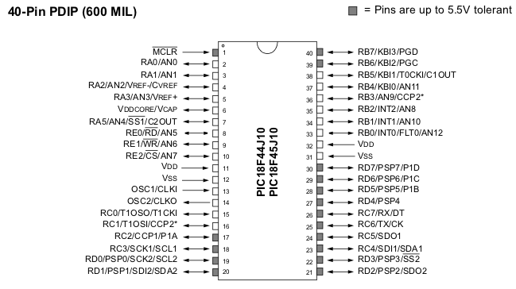

GPS Pinout Verification:

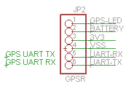

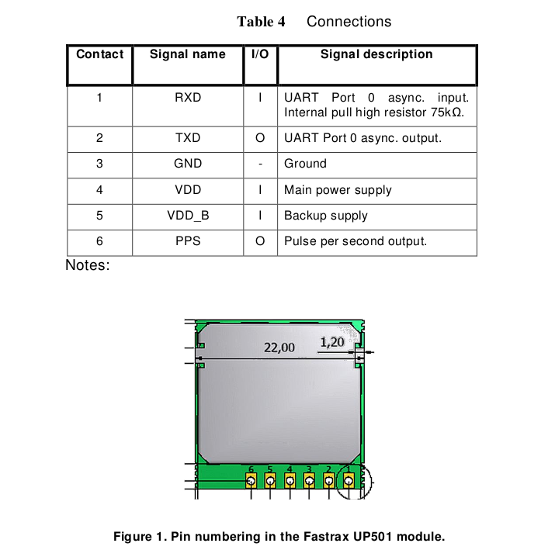

PICKIT Pinout Verification:

